**LAB 1**

**1. Write program to test Hello World.**

#include<iostream>

using namespace std;

int main()

{

cout<<"Hello World ";

return 0;

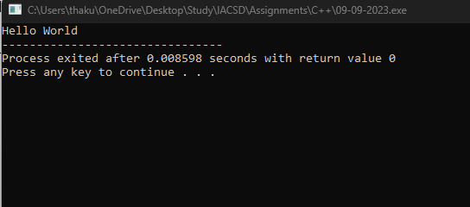}

**2. Write a program to adddition of two numbers .**

#include<iostream>

using namespace std;

int main()

{

int no_1,no_2;

cout<<"Enter the two numbers you want to add: ";

cin>>no_1>>no_2;

cout<<"Sum = "<<no_1+no_2;

return 0;

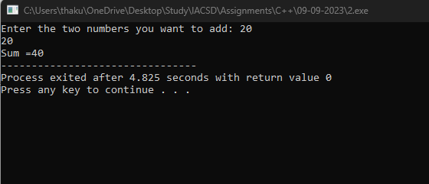}

**3. Write a program to swap two numbers.**

#include<iostream>

using namespace std;

int main()

{

int n1,n2;

cout<<"Enter number 1 and number 2:"<<endl;

cin>>n1>>n2;

cout<<"n1 = "<<n1<<"\nn2 = "<<n2<<endl;

n1=n1+n2;

n2=n1-n2;

n1=n1-n2;

cout<<"After swapping:\n"<<"n1 = "<<n1<<"\nn2 = "<<n2;

return 0;

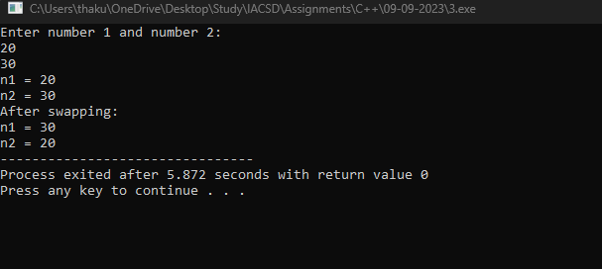}

**4. Write a program to accept an integer and check if it is even or odd.**

#include<iostream>

using namespace std;

int main()

{

int n;

cout<<"Enter a number : "<<endl;

cin>>n;

if(n%2==0)

{

cout<<"Number "<<n<<" is even."<<endl;

}

else

{

cout<<"Number "<<n<< " is odd.";

}

return 0;

}

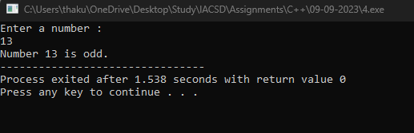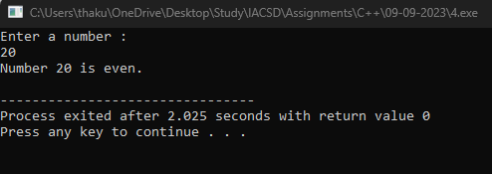

**5. Write a program to accept a number and check if it is divisible by 5 and 7.**

#include<iostream>

using namespace std;

int main()

{

int n;

cout<<"Enter a Number :"<<endl;

cin>>n;

if(n%5==0&&n%7==0)

{

cout<<"Number is divisible by 5 and 7."<<endl;

}

else

cout<<"Number "<<n<<" is divisible by 5 and 7."<<endl;

return 0;

}

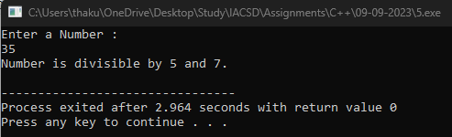

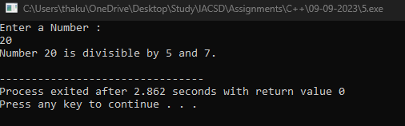

**6. Write a program, which accepts annual basic salary of an employee and calculates and displays the**

**Income tax as per the following rules.**

**Basic: < 1, 50,000 Tax = 0**

**1, 50,000 to 3,00,000 Tax = 20%**

**> 3,00,000 Tax = 30%**

#include<iostream>

using namespace std;

int main()

{

int b;

cout<<"Enter the basic salary : "<<endl;

cin>>b;

if(b<=150000)

{

cout<<"Income Tax = 0 "<<b<<endl;

}

else if(150000<b<300000)

{

cout<<"Income Tax = "<<0.2*(b-150000)<<endl;

}

else

{

cout<<"Income Tax = "<<0.2*150000+0.3*(b-300000);

}

return 0;

}

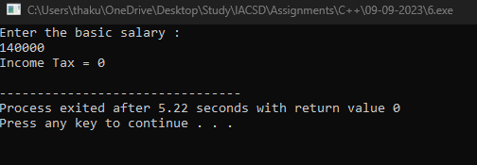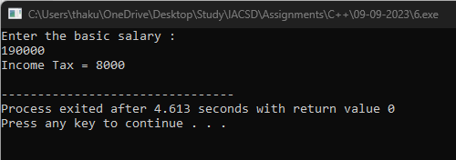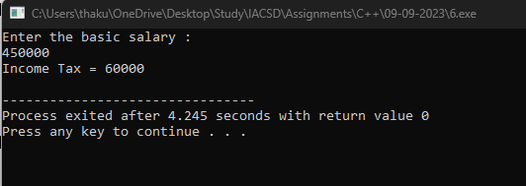

**7. Accept a lowercase character from the user and check whether the character is a vowel or consonant.**

**(Hint: a, e, i, o, u are vowels)**

#include<iostream>

using namespace std;

int main()

{

char aph;

bool flag=false;

char a[10]={'A','E','I','O','U','a','e','i','o','u'};

cout<<"Enter a letter: ";

cin>>aph;

for(int i=0;i<10;i++)

{

if(aph==a[i])

{

flag=true;

break;

}

else

flag=false;

}

if(flag==true)

cout<<"The alphabet you have entered is vowel";

else

cout<<"The alphabet you have entered is consonant";

return 0;

}

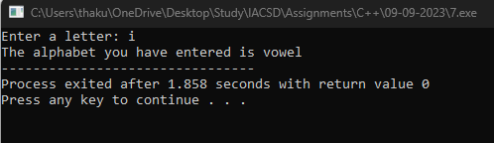

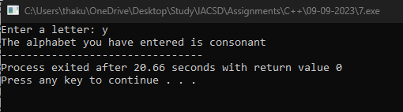

**8. Write a program to input angles of a triangle and check whether triangle is valid or not.**

#include<iostream>

using namespace std;

int main()

{

int a,b,c;

cout<<"Enter the angles of triangle: "<<endl;

cin>>a>>b>>c;

if(a+b+c==180)

cout<<"Triangle is valid.";

else

cout<<"Triangle is invalid.";

return 0;

}

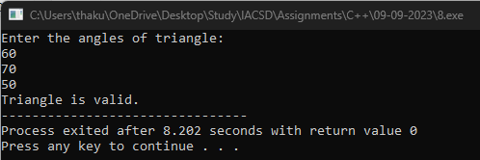

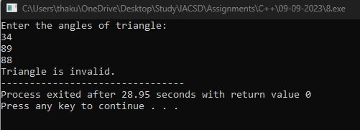

**9:Write a program to find factorial of a given number. ex:no5 fact=5*4*3*2*1=120**

#include<iostream>

using namespace std;

int main()

{

int n,fact=1;

cout<<"Enter the number to find factorial : ";

cin>>n;

for(int i=1;i<=n;i++)

{

fact=fact*i;

}

if(n==0||n==1)

cout<<"Factorial of "<<n<<" is = 1"<<endl;

else

cout<<"Factorial of "<<n<<" is = "<<fact<<endl;

return 0;

}

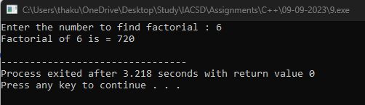

**10:Write a program to find m to the power n. m=3 and n=4 so 3*3*3*3**

#include<iostream>

using namespace std;

int main()

{

int base,pow,res=1;

cout<<"Enter base and power :"<<endl;

cin>>base>>pow;

for(int i=1;i<=pow;i++)

res=res*base;

cout<<base<<" to the power "<<pow<<" = "<<res;

}

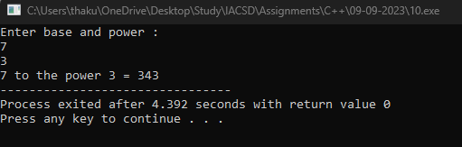

**11.Check if number is a prime number or not.:**

#include<iostream>

using namespace std;

int main()

{

int n;

bool flag=false;

cout<<"Enter the number : "<<endl;

cin>>n;

for(int i=2;i<n;i++)

{

if(n%i==0)

{flag=true;

break;

}

else

flag=false;

}

if(flag==false)

cout<<n<<" is Prime";

else

cout<<n<<" is not Prime";

return 0;

}

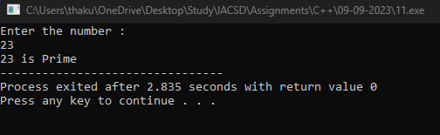

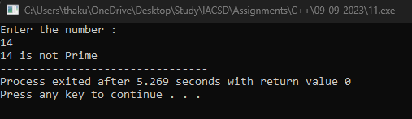

**12:Sum of series : 1+2+3+….+n**

#include<iostream>

using namespace std;

int main()

{

int n,sum=0;

cout<<"Enter the number upto which you want sum of series: "<<endl;

cin>>n;

for(int i=1;i<=n;i++)

sum=sum+i;

cout<<"Sum of series upto "<<n<<" is "<<sum;

return 0;

}

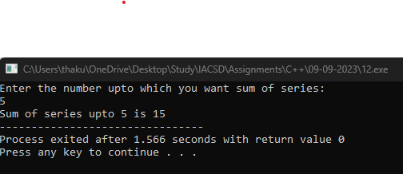

**13.Check wheather the number is palindrome or not?**

#include<iostream>

using namespace std;

int main()

{

int temp,n,c=0;

cout<<"Enter a number:";

cin>>n;

temp=n;

while(n!=0)

{

c=c*10+n%10;

n=n/10;

}

cout<<"Number = "<<temp<<"\nAfter swap, number = "<<c<<endl;

if(c==temp)

cout<<temp<<" is Pallindrome ";

else

cout<<temp<<" is not Pallindrome ";

return 0;

}

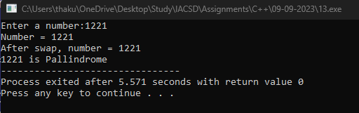

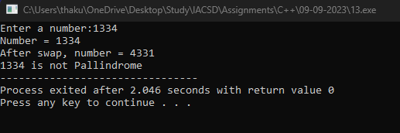

**14.Write a program to find sum of all even and odd numbers between 1 to n.**

#include<iostream>

using namespace std;

int main()

{

int n,sum_odd=0,sum_even=0;

cout<<"Enter the number upto which you want sum: ";

cin>>n;

for(int i=1;i<=n;i++)

{

if(i%2==0)

sum_even=sum_even+i;

else

sum_odd=sum_odd+i;

}

cout<<"Sum of even numbers from 1 to "<<n<<" is "<<sum_even<<endl;

cout<<"Sum of odd numbers from 1 to "<<n<<" is "<<sum_odd<<endl;

return 0;

}

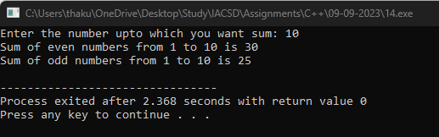

**15.Write a program to enter a number and print its reverse.**

#include<iostream>

using namespace std;

int main()

{

int n,temp,c=0;

cout<<"Enter a number : ";

cin>>n;

temp=n;

while(n!=0)

{

c=c*10+n%10;

n=n/10;

}

cout<<"The number is "<<temp<<endl;

cout<<"The reversed number is "<<c;

return 0;

}

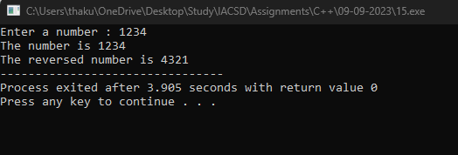

**16.Write a program to print all Prime numbers between 1 to n.**

#include<iostream>

using namespace std;

bool isPrime(int n)

{

if(n==0||n==1)

return false;

for(int i=2;i<n;i++)

{

if(n%i==0)

return false;

}

return true;

}

int main()

{

int N;

cout<<"Enter a number upto which you want to print the prime numbers :"<<endl;

cin>>N;

for(int i=1;i<=N;i++)

{

if(isPrime(i))

cout<<i<<" ";

}

return 0;

}

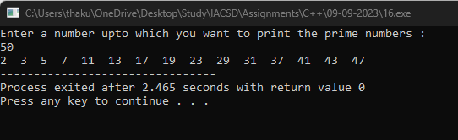

**17.Write a program to check entered number is Armstrong number or not.**

#include<bits/stdc++.h>

using namespace std;

int main()

{

int n,a,temp1,temp2,sum=0,count=0;

cout<<"Enter a Number : "<<endl;

cin>>n;

temp1=temp2=n;

while(n!=0)

{

n=n/10;

count++;

}

for(int i=1;i<=count;i++)

{

a=temp1%10;

sum=sum+pow(a,count);

temp1=temp1/10;

}

if(temp2==sum)

cout<<"The number "<<temp2<<" is Armstrong ";

else

cout<<"The number "<<temp2<<" is not Armstrong";

return 0;

}

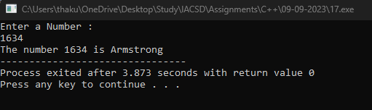

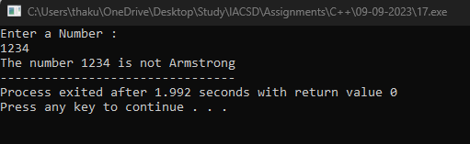

**18.Write a program to find greatest of three numbers using nested if-else.**

#include<bits/stdc++.h>

using namespace std;

int main()

{

int n1,n2,n3;

cout<<"Enter 3 numbers: "<<endl;

cin>>n1>>n2>>n3;

if(n1>n2)

{

if(n1>n3)

cout<<n1<<" is greatest number.";

else

cout<<n3<<" is greatest number.";

}

else

{

if(n2>n3)

cout<<n2<<" is the greatest number.";

else

cout<<n3<<" is the greatest number.";

}

return 0;

}

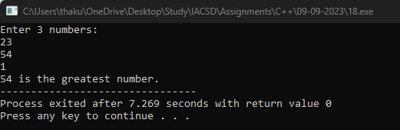

**19.Create menu driven program for Pizza Shop.And display total amount.**

#include<bits/stdc++.h>

using namespace std;

int main()

{

double sum=0,Pizza=200,Burger=150,Fries=100,Sandwich=80,Coffee=90;

int choice;

cout<<"\n 1.Pizza \n 2.Burger \n 3.Fries \n 4.Sandwich \n 5.Coffee \n 6.Exit"<<endl;

do

{

cout<<"Enter choice"<<endl;

cin>>choice;

if(choice==1)

sum=sum+200;

else if(choice==2)

sum=sum+150;

else if(choice==3)

sum=sum+100;

else if(choice==4)

sum=sum+80;

else if(choice==5)

sum=sum+90;

else if(choice>6)

cout<<"Enter a valid choice"<<endl;

}while(choice!=6);

cout<<"Total Amount = "<<sum;

return 0;

}

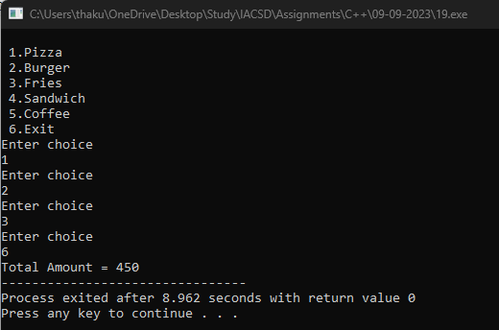

**20.Accept a single digit from the user and display it in words. For example, if digit entered is 9, display Nine.**

#include<iostream>

using namespace std;

int main()

{

int choice;

cout<<"Enter a number:";

cin>>choice;

switch(choice)

{

case 1:

cout<<"One";

break;

case 2:

cout<<"Two";

break;

case 3:

cout<<"Three";

break;

case 4:

cout<<"Four";

break;

case 5:

cout<<"Five";

break;

case 6:

cout<<"Six";

break;

case 7:

cout<<"Seven";

break;

case 8:

cout<<"Eight";

break;

case 9:

cout<<"Nine";

break;

}

return 0;

}

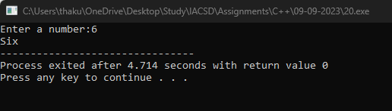

**21. Write a program, which accepts two integers and an operator as a character (+ - * / ), performs the**

**corresponding operation and displays the result.**

#include<iostream>

using namespace std;

int main()

{

int n1,n2;

char choice;

cout<<"Enter two numbers:"<<endl;

cin>>n1>>n2;

cout<<"Enter Operator:";

cin>>choice;

switch(choice)

{

case '+':

cout<<"n1+n2 = "<<n1+n2;

break;

case '-':

cout<<"n1-n2 = "<<n1-n2;

break;

case '/':

cout<<"n1/n2 = "<<(double)n1/n2;

break;

case '*':

cout<<"n1*n2 = "<<n1*n2;

break;

}

return 0;

}

